Yoga Poses

Question 1
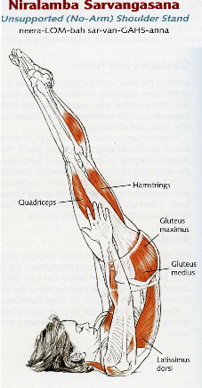
Begin by making a list of the muscles from the Top 20 that are used in this yoga pose. Remember that some of the Top 20 muscles may not be illustrated, but can still be used in these poses; you must include those in your answer.
Once you have made your list, answer the following question:
For each muscle in your Top 20 list, describe its role in the pose. For full credit, your description must include the joint that is affected by each muscle and the action of that muscle on that joint (remember, a muscle action at a joint is the result of the force the muscle applies to the bones on opposite sides of the joint; movement is one possible result of this action).
For example, if the arm is held up parallel to the ground and then horizontally adducted so that it is pointing straight ahead, then the pectoralis major is acting in horizontal adduction and flexion of the glenohumeral joint; the latissimus dorsi is acting in horizontal abduction of the glenohumeral joint to resist adduction; the deltoideus is acting in flexion and abduction of the glenohumeral joint.
The flexors of the GHJ are working against the force of gravity; the horizontal adductors are working to move the GHJ into the pose and to stabilize the joint against the actions of other muscles; and the horizontal abductors are working to stabilize the GHJ against further horizontal adduction.
When in doubt, ask yourself what would happen with the body in that pose if any of the Top 20 muscles were not acting.

Question 2
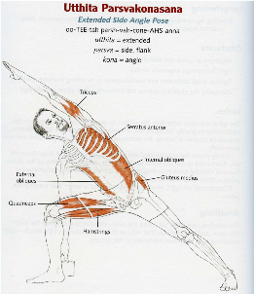
Begin by making a list of the muscles from the Top 20 that are used in this yoga pose. Remember that some of the Top 20 muscles may not be illustrated, but can still be used in these poses; you must include those in your answer.
Once you have made your list, answer the following question:
For each muscle in your Top 20 list, describe its role in the pose. For full credit, your description must include the joint that is affected by each muscle and the action of that muscle on that joint (remember, a muscle action at a joint is the result of the force the muscle applies to the bones on opposite sides of the joint; movement is one possible result of this action).
For example, if the arm is held up parallel to the ground and then horizontally adducted so that it is pointing straight ahead, then the pectoralis major is acting in horizontal adduction and flexion of the glenohumeral joint; the latissimus dorsi is acting in horizontal abduction of the glenohumeral joint to resist adduction; the deltoideus is acting in flexion and abduction of the glenohumeral joint.
The flexors of the GHJ are working against the force of gravity; the horizontal adductors are working to move the GHJ into the pose and to stabilize the joint against the actions of other muscles; and the horizontal abductors are working to stabilize the GHJ against further horizontal adduction.
When in doubt, ask yourself what would happen with the body in that pose if any of the Top 20 muscles were not acting.

Top 20 Muscles

Question 3
Complet the missing parts.

Tibialis anterior
What are the principal attachments of this muscle, and what effect is produced when this muscle contracts? Use the prompts below to guide your answers for this muscle.
This muscle is located …
It appears ...
The muscle's principal attachments are...
And....
When it applies tension to...
it acts on the …. joint,
which is a … joint
which allows ….
in the …. plane(s).
Since the muscle is oriented …
the joint, its action can produce….
of the …................

Question 4
Gluteus maximus
What are the principal attachments of this muscle, and what effect is produced when this muscle contracts? Use the prompts below to guide your answers for this muscle.
This muscle is located …
It appears ...
The muscle's principal attachments are...
And....
When it applies tension to...
it acts on the …. joint,
which is a … joint
which allows ….
in the …. plane(s).
Since the muscle is oriented …
the joint, its action can produce….
of the …................

Question 5
Deltoid
What are the principal attachments of this muscle, and what effect is produced when this muscle contracts? Use the prompts below to guide your answers for this muscle.
This muscle is located …
It appears ...
The muscle's principal attachments are...
And....
When it applies tension to...
it acts on the …. joint,
which is a … joint
which allows ….
in the …. plane(s).
Since the muscle is oriented …
the joint, its action can produce….
of the …................

Question 6
Sternocleidomastoid
What are the principal attachments of this muscle, and what effect is produced when this muscle contracts? Use the prompts below to guide your answers for this muscle.
This muscle is located …
It appears ...
The muscle's principal attachments are...
And....
When it applies tension to...
it acts on the …. joint,
which is a … joint
which allows ….
in the …. plane(s).
Since the muscle is oriented …
the joint, its action can produce….
of the …................

Question 7
Infraspinatus
What are the principal attachments of this muscle, and what effect is produced when this muscle contracts? Use the prompts below to guide your answers for this muscle.
This muscle is located …
It appears ...
The muscle's principal attachments are...
And....
When it applies tension to...
it acts on the …. joint,
which is a … joint
which allows ….
in the …. plane(s).
Since the muscle is oriented …
the joint, its action can produce….
of the …................

Sports Injuries

Question 8
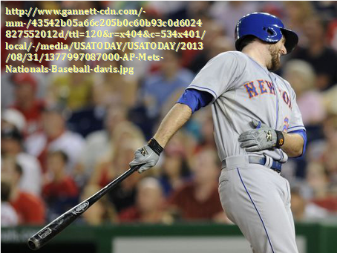
Injuries to the abdominal oblique muscles are common in baseball pitchers and hitters. Left-hand‒hitter Ike Davis suffered a right-side “oblique” injury after hitting a fly ball.
- What are the muscles that are included in the group labeled by the term "abdominal oblique" muscles?
- What are their actions at which joints?
- In looking at the photograph, how have relevant joints been moved so that the structures to which they attach are not in normal anatomic position? Describe these positions in standard anatomic terms: adduction/abduction, medial/lateral rotation, flexion/extension, and so on.
- What caused these deviations from normal anatomic position (for example, impact, momentum, resistance of substrate, and so on)?
- How do the muscles in your answer above act to stabilize the joints (to prevent further deviation) and/or return them to normal anatomic position. Finally, choose which ONE of the candidates as the most likely one that is injured.
- Give specific evidence that would isolate this muscle as the one injured. What action at which joints does the injured muscle perform that the others do not which would put it at risk
NOTE: The muscles involved in this problem are not limited to those in the Top 20 handout.

Anatomy in Art

Question 9
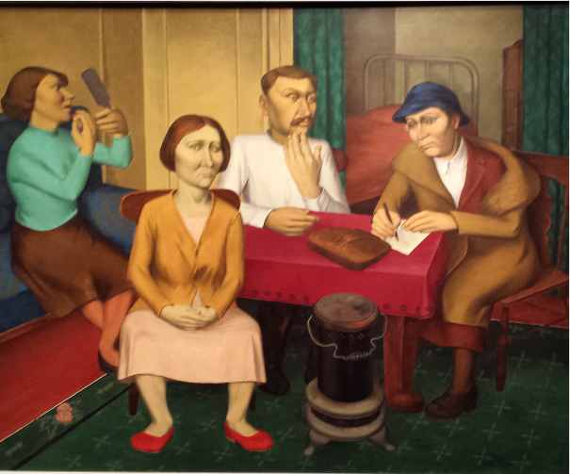
For O Louis Guglielmi's painting Relief Blues examine the female figure to the left of center in the foreground.
To solve this problem of anatomic accuracy in figurative painting, start with the basic anatomic landmarks that can provide information about the underlying structures.
- First, identify the anatomic landmarks that you can use to locate features of the musculoskeletal system from which we can estimate body proportions.
- How do the body proportions in the painting compare to the “standard” proportions? Do all the figures in the piece have similar proportions?
- Does the Guglielmi painting show body proportions that are unrealistic, or would you conclude that he was capturing one example of the normal variation in anatomic form and proportion in the human body? HINT: Think about using a part of the body as a reference for other measurements, as you did with the "rule of heads" lab activity.

